To create new server and nodemon :

Cmd: npm init

npm install nodemon

and inside Json file write write : start: nodemon index.js

 "scripts": {

    "test": "echo \"Error: no test specified\" && exit 1",

    "start":"nodemon index.js"

  },

And server is ok

For index.js

const http = require('http');

const PORT = 3000;

const hostname = '127.0.0.1';

const MyServer = http.createServer((req,res)=>{

    res.end(" Bangladesh");

});

MyServer.listen(PORT,hostname,()=>{

    console.log(`Server is running successfully at http://${hostname}:${PORT}`);

})

For routing:

const MyServer = http.createServer((req,res)=>{

    if(req.url === "/"){

        fs.readFile("./views/index.html", (err,data)=>{

            res.writeHead(200, {"content-Type": "text/html"});

            res.write(data);

            res.end();

        })

Exprees.js:

$ nmp init

$ npm install express nodemon

And then to create express server : in app.js

const express = require('express');

const app = express();

module.exports = app;

After That in index.js

const app = require('./app');

const PORT = 3000;

app.listen(PORT, ()=>{

    console.log("Server is running");

});

Expresss js route:

app.get('/home',(req,res)=>{

    res.sendFile(__dirname + "/views/index.html");

});

Reqest quary:

app.get('/',(req,res)=>{

    const id = req.query.id;

    res.end(id);

});

Request params:

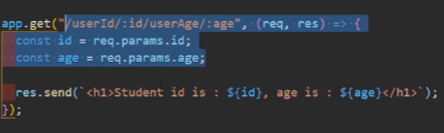

To post request with json data: body parser install from npmjs

app.use(bodyParser.urlencoded({ extended: false }));

app.use(bodyParser.json());

app.post('/user', (req,res)=>{

    const name = req.body.name;

    res.send(`Wellcome ${name}`);

});